INT102 Lab 1 Web Essentials

1. Open Google Chrome Browser
2. In the address bar, enter the SIT’s home page as follow:

http://www.sit.kmutt.ac.th

1. What happens after you type the above URL?

……**It will go to website “https://www.sit.kmutt.ac.th”**……………………………

1. Try to move cursor over the content in the page such as image or text.

* The cursor icon might be change from the pointer icon to hand icon. If the icon is hand, try to click the mouse. What happens? **It’s will go to another webpage.**
* In order to go back to the previous page, click Back icon (🡨) in the toolbar on Browser

1. Click Start Menu and type “Command”. The windows will search program that match with the entered text. Click “Command Prompt” and it will open the Command Prompt window.

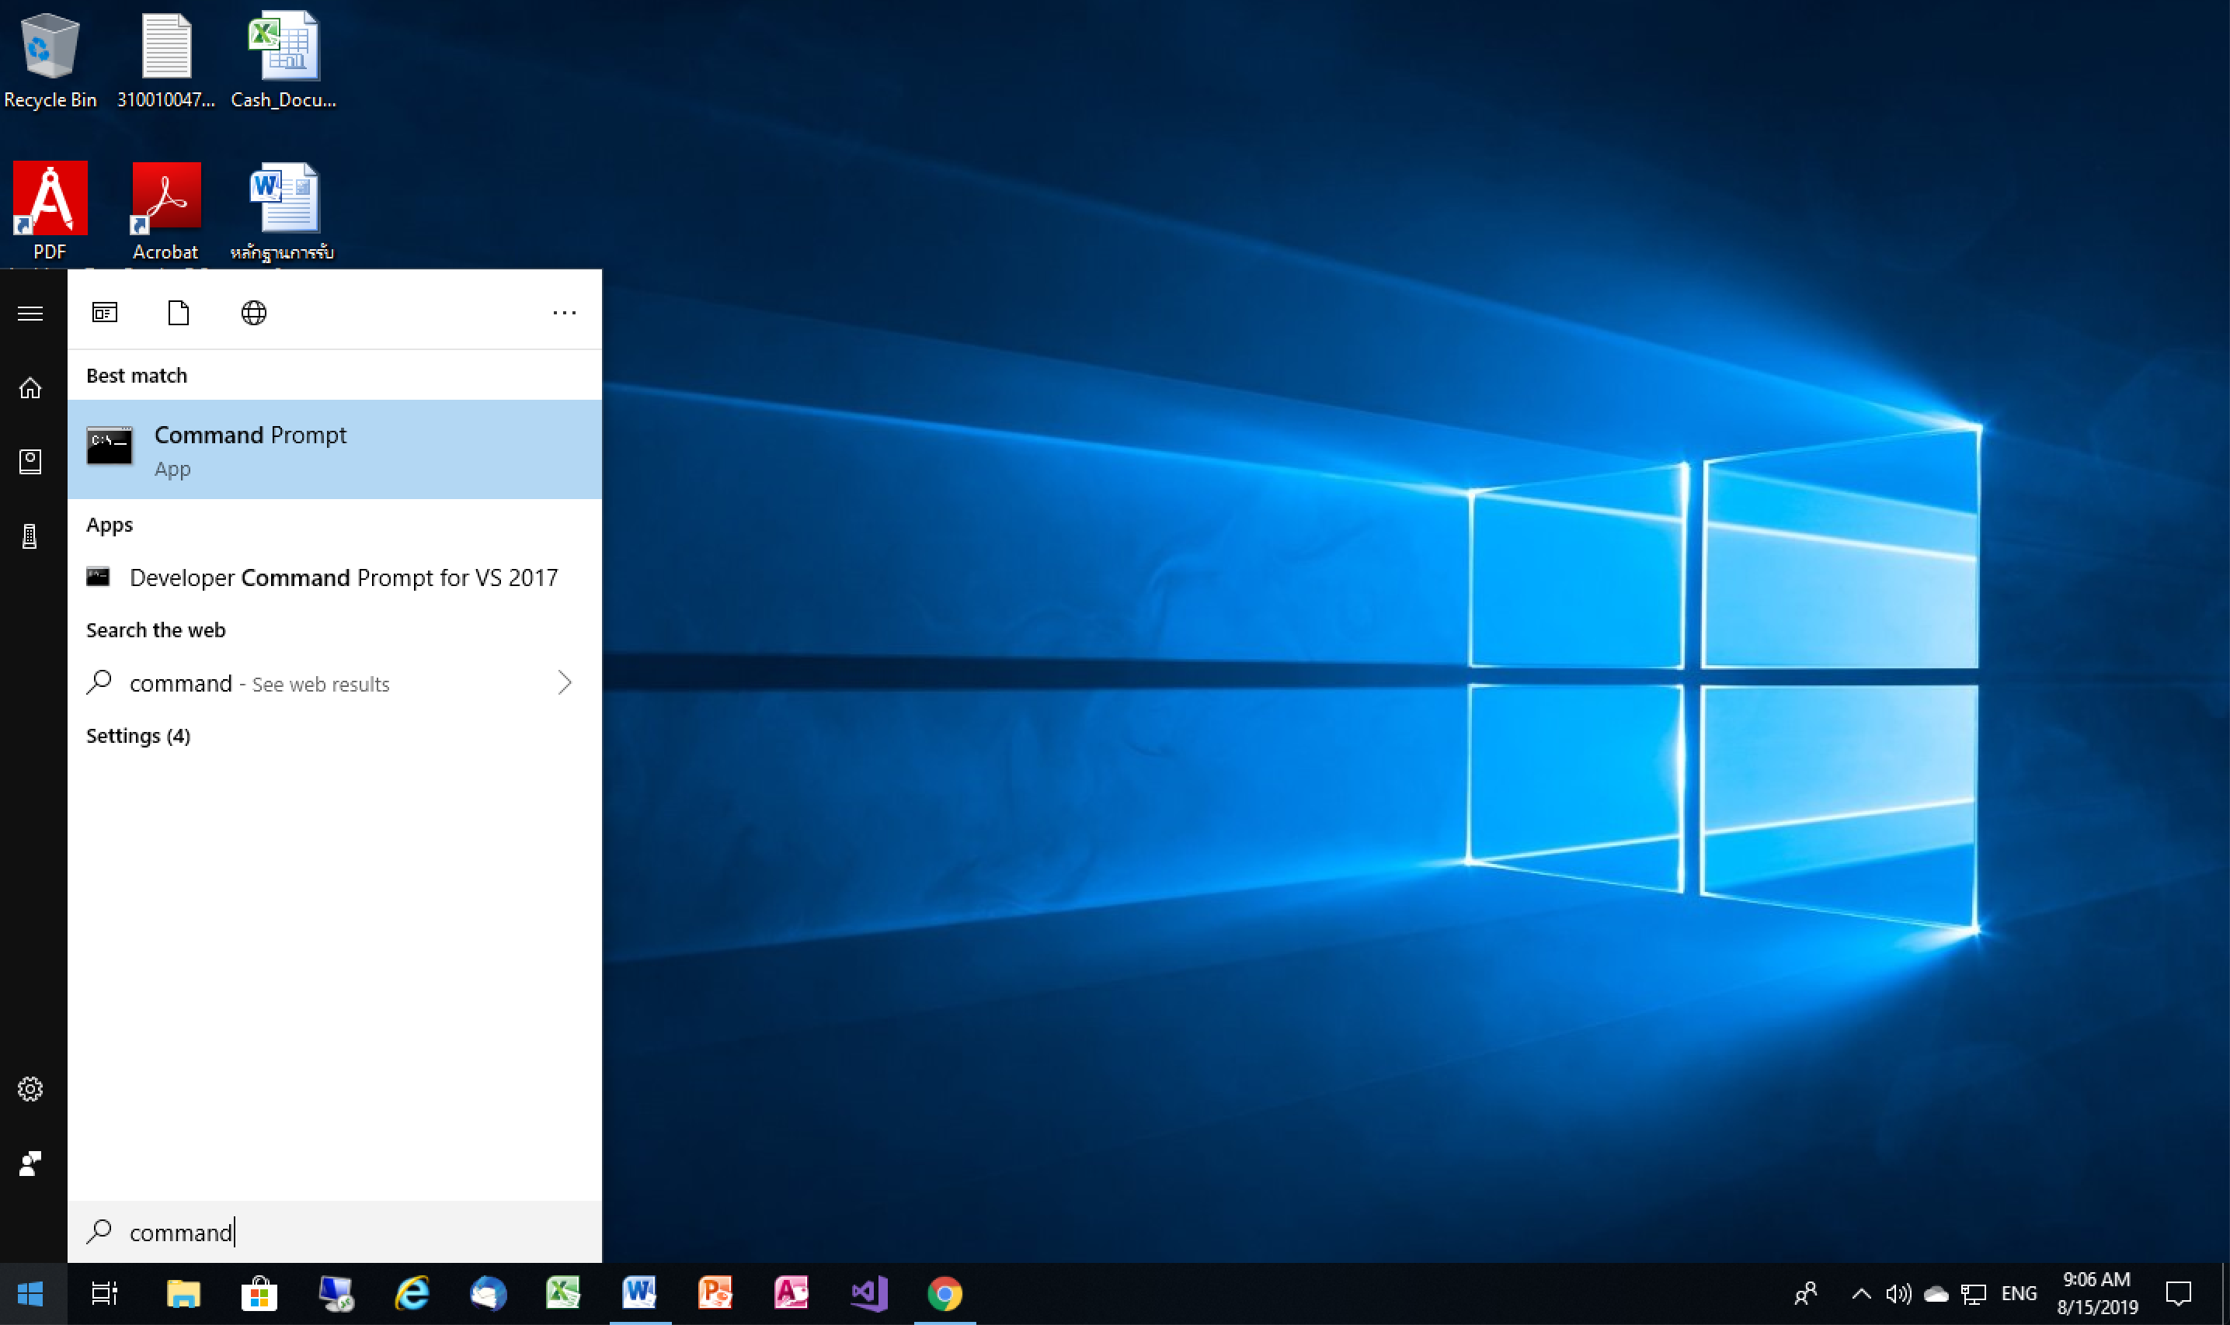

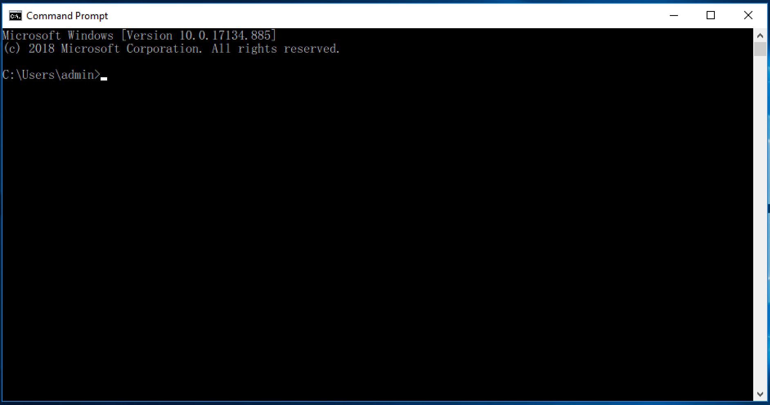

1. Use the PING command to test reachability of a host on an IP network. Type the following command:

C:\Users\int102> ping [www.sit.kmutt.ac.th](http://www.sit.kmutt.ac.th)

What does the output show?

**Pinging www.sit.kmutt.ac.th [202.44.9.116] with 32 bytes of data:**

**Reply from 202.44.9.116: bytes=32 time=5ms TTL=47**

1. Try to ping the SIT’s eLearning by using the following command:

C:\Users\int102> ping leaning.sit.kmutt.ac.th

Does it have different IP address from the SIT’s web site?

… **Ping request could not find host leaning.sit.kmutt.ac.th. Please check the name and try again.** ……………………………………………………………

1. On the Chrome browser, enter the following URL:

web.sit.kmutt.ac.th/sanit/int102

What will you see the page in the browser?

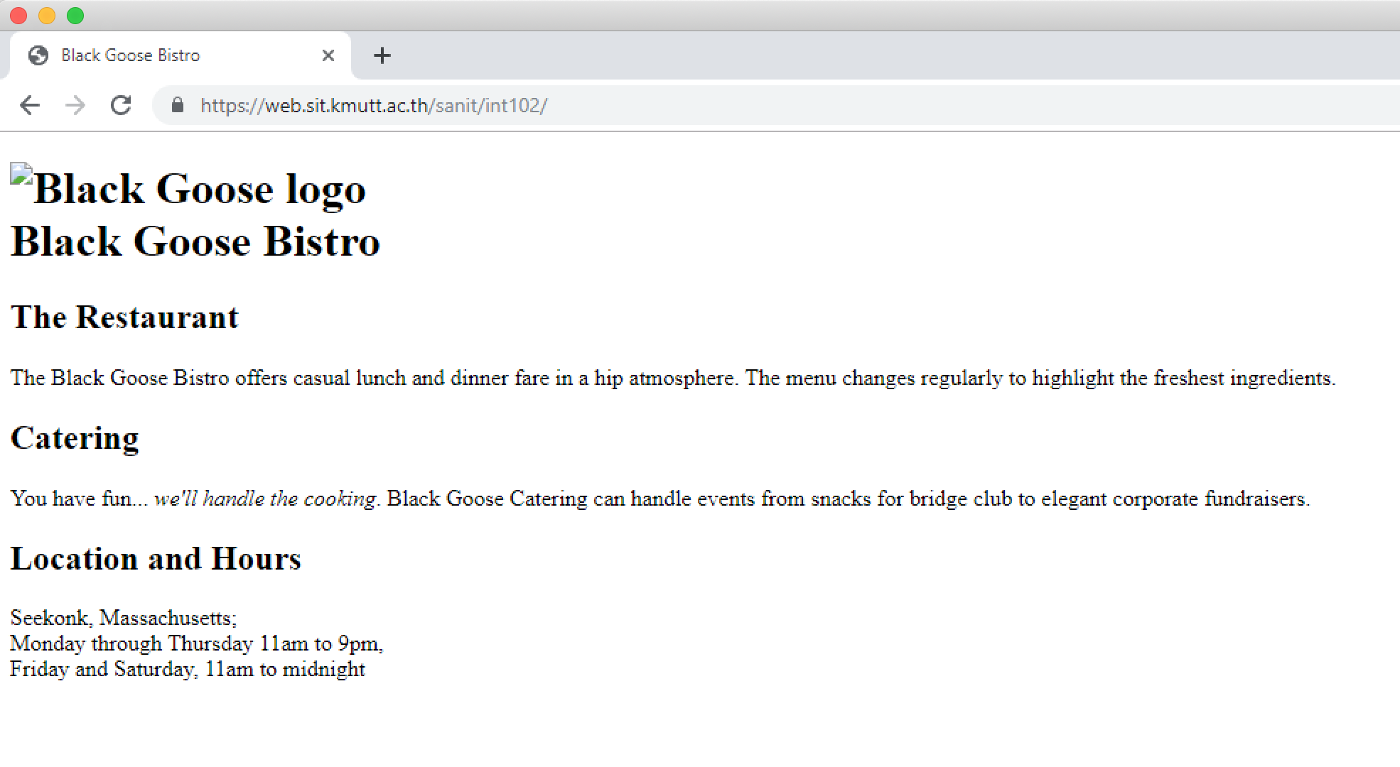

1. Try to enter the above URL with the specific document like index.html as follows:

web.sit.kmutt.ac.th/sanit/int102/index.html

What will you see the page in the browser?

………………………………………………………………………………..

1. Try to change the document name to different name or different document type such as Index.html, index.htm

What happen?

………………………………………………………………………………..

1. Try to enter the above URL with the specific document like index2.html as follows:

web.sit.kmutt.ac.th/sanit/int102/index2.html

What will you see the page in the browser?

………………………………………………………………………………..

1. In order to view the page source, Right-click > View page source (Ctrl+U) or inspect

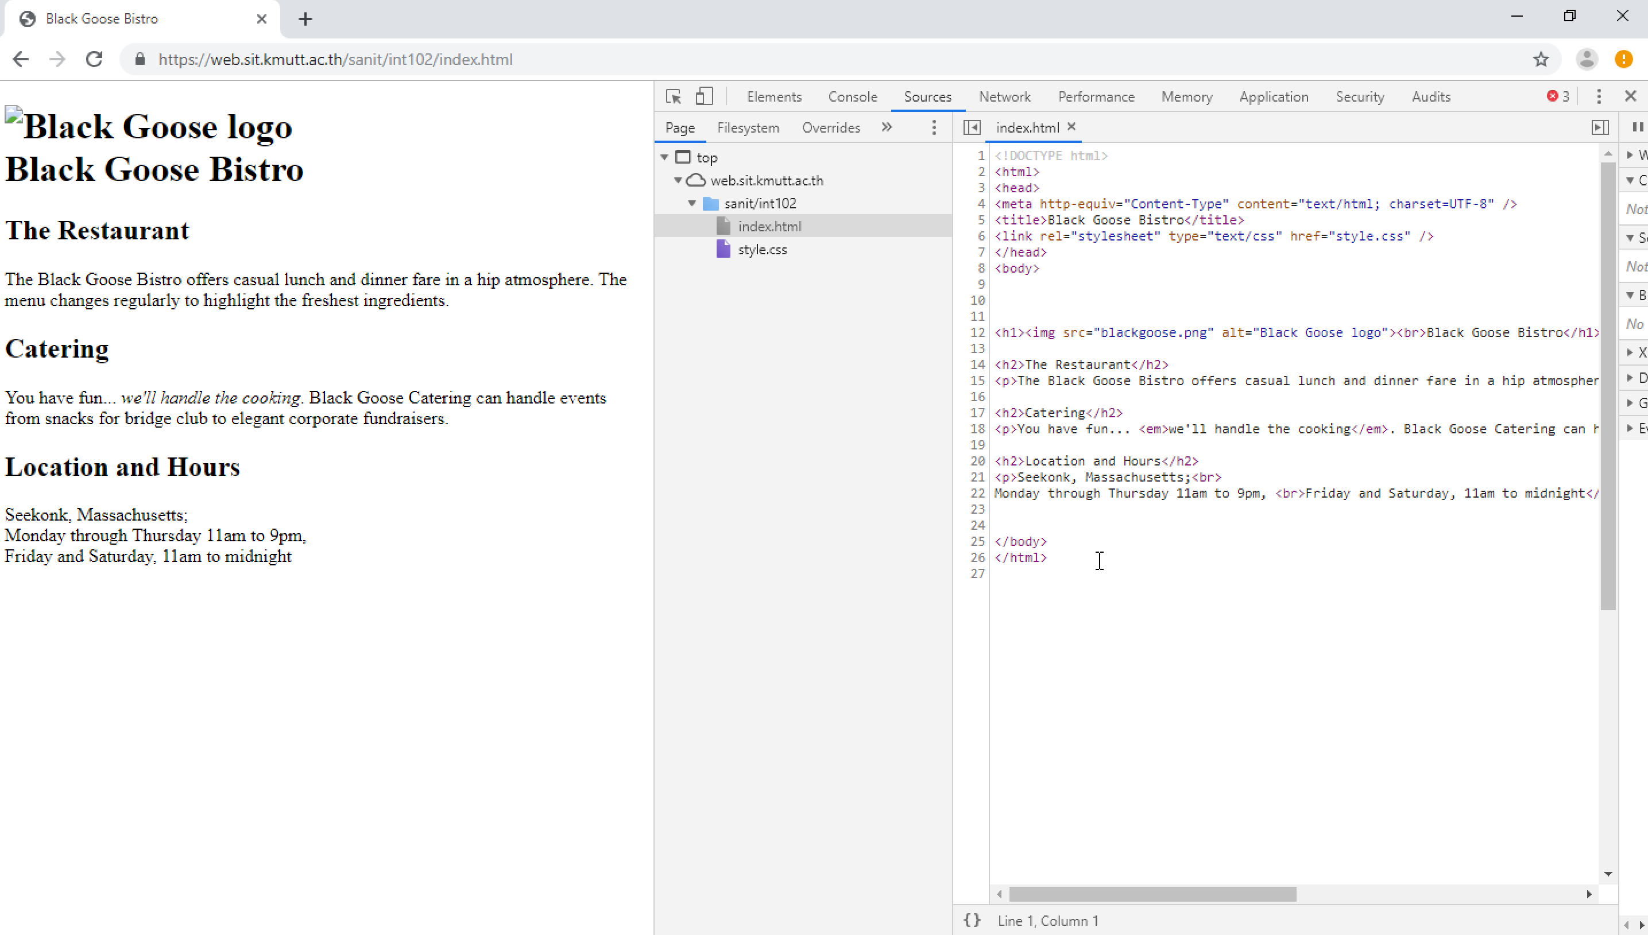

1. Try to view the page source of the document index.html. Why does the index.html show the image or layout in the same way as the index2.html?

……………………………………………………………………………….